RESOLUTION NO.__________

RE: CERTIFICATE OF APPROPRIATENESS UNDER THE
PROVISIONS OF THE ACT OF THE PENNSYLVANIA
LEGISLATURE 1961, JUNE 13, P.L. 282 (53
SECTION 8004) AND BETHLEHEM ORDINANCE NO.
3952 AS AMENDED.

WHEREAS, it is proposed to replace the siding in the rear of the home at
27 E. Church St..

NOW, THEREFORE, BE IT RESOLVED by the Council of the City of Bethlehem that a Certificate of Appropriateness is hereby granted for the proposal.

Sponsored by: (s)

(s)

ADOPTED BY COUNCIL THIS DAY OF

(s)
President of Council

ATTEST:

(s)
City Clerk

HISTORICAL & ARCHITECTURAL REVIEW BOARD

The applicant proposes to remove and replace the siding in the rear of
the home at 27 E. Church Street.
APPLICATION #1:

Mark & Alane Nebbia
27 E. Church St., Bethlehem, PA 18018

OWNER:

__________________________________________________________________

The Board upon motion by Marsha Fritz and seconded by Nancy Shelly adopted the proposal that City Council issue a Certificate of Appropriateness for the following:

- Re-siding the rear of the home with Arctic White Hardie siding.

- To be installed horizontally with 4” exposure.

3. Also installing appropriate trim supplied by Hardie products.

4. The motion was unanimously approved.

__________________________________________________________________________

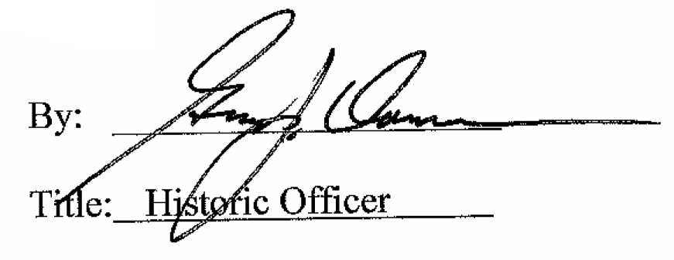

Date of Meeting: September 2, 2015

